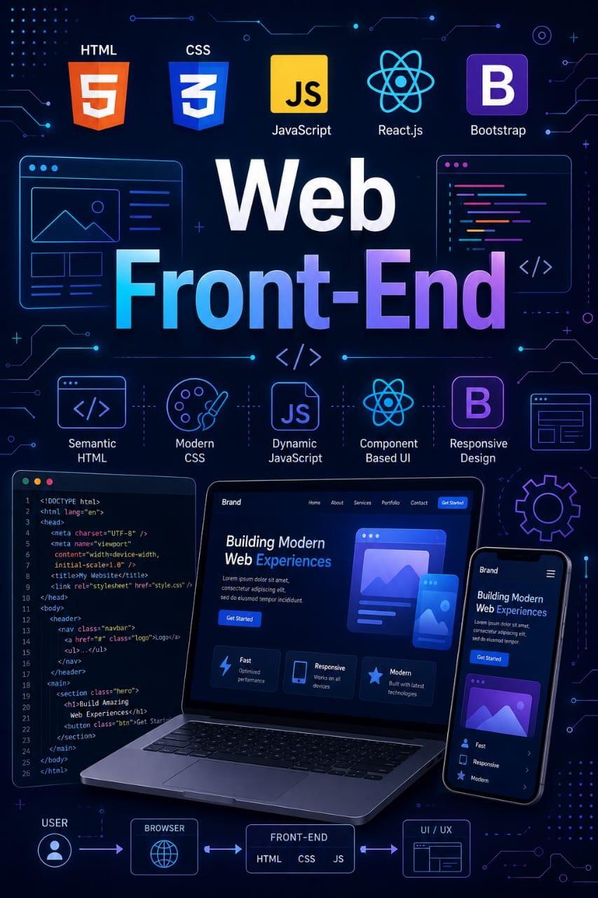

Web Front-End

By Jawad Jammoul

